Assignment 1

Tree Based Search

Author
Mark Saleh 103994313

Table of Contents

Glossary 2
Instructions 2
Introduction 2
Search Algorithms and Implementation 4
Depth-First Search 4
Breadth-First Search 5
Greedy Best-First Search 7
A* Search 9
Custom Search 1 10
Custom Search 2 11
Testing 12
No method 12
Invalid method 12
Invalid filename 13
No reachable goal 13
Generate GUI with no reachable goal 13
Generate GUI with no reachable goal (visited error temporarily patched) 13
Walls block goal 14
3 goals instead of 2 14
Goal is in a wall 15
Goal is in initial position 16
Research 16
Resources 17

Glossary
- Frontier: The set of nodes that are candidates for expansion
- GUI (graphical user interface): A visual interface that allows the user to see and interact with software
- Heuristic: A technique used to find a practical solution, often when a precise one is infeasible
- Node: A point in the search space
- Path: A sequence of nodes that leads from an initial state to a goal
- Search algorithm: A methodical procedure that finds a solution to a problem

Instructions
To use the provided code, open the terminal, navigate to the RobotNav directory, and enter the following:
python search.py resource.txt <method>
The following are valid methods:
- dfs
- bfs
- gbfs
- as
- cus1
- cus2
- lps
These are not case-sensitive. To see the GUI, append “gui” (not case sensitive either) after the command. For example, this command should return a depth first search with the GUI:
python search.py resource.txt DFS GUI
A batch file is also provided, and can be run by the following command (although it does not support the GUI):
.\search.bat resource.txt <method>

Introduction
The problem in this assignment was to design several search algorithms that would guide an AI robot. Figure 1 is a visualisation of the environment:
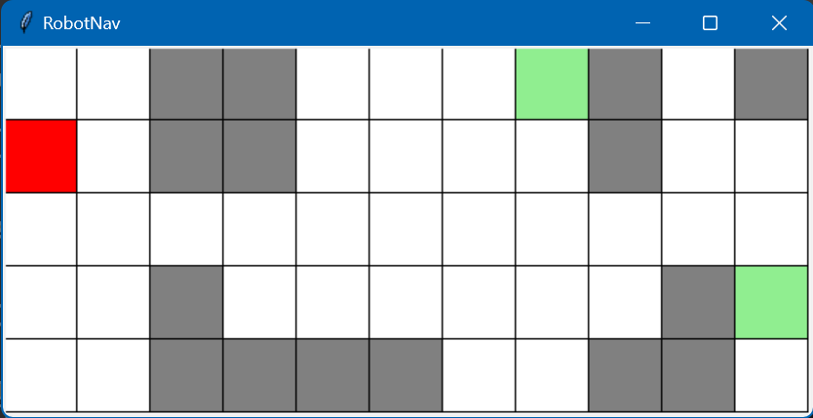
Figure 1: The environment of the robot
The red square represents the initial state of the robot at the coordinates (0,1). The two green squares at the coordinates (7,0) and (10,3) are the goals. The objective of the robot is to reach either one of them. The grey squares are impassable walls.
The assignment’s instructions specified four search algorithms to program: Depth-First Search (DFS), Breadth-First Search (BFS), Greedy Best-First Search (GBFS) and A* Search (AS). Additionally, two custom search algorithms, Beam Search (CUS1) and Iterative Deepening A* Search (CUS2), were to be devised. Although Longest Path Search (LPS) was initially created due to a misunderstanding, it was retained as an unconventional addition to the codebase.
Running a search algorithm returns an output in the following format:
filename method
goal number_of_nodes
path
The number_of_nodes quantifies the nodes the program created while running. This allows for comparisons of the efficiency of each search algorithm.
Furthermore, a GUI was created to display a map of the environment. The legend in this GUI is as follows:
- white = background
- grey = walls
- light green = goals
- red = initial state and path
- light blue = visited squares

Search Algorithms and Implementation

Depth-First Search
A depth-first search (DFS) is an algorithm in which the AI begins at a node and explores as far as possible before backtracking. It is uninformed, meaning that it does not know the coordinates of the goal and can only recognise it when it is reached. Figure 2 illustrates the order in which nodes on a tree might be visited by a DFS.
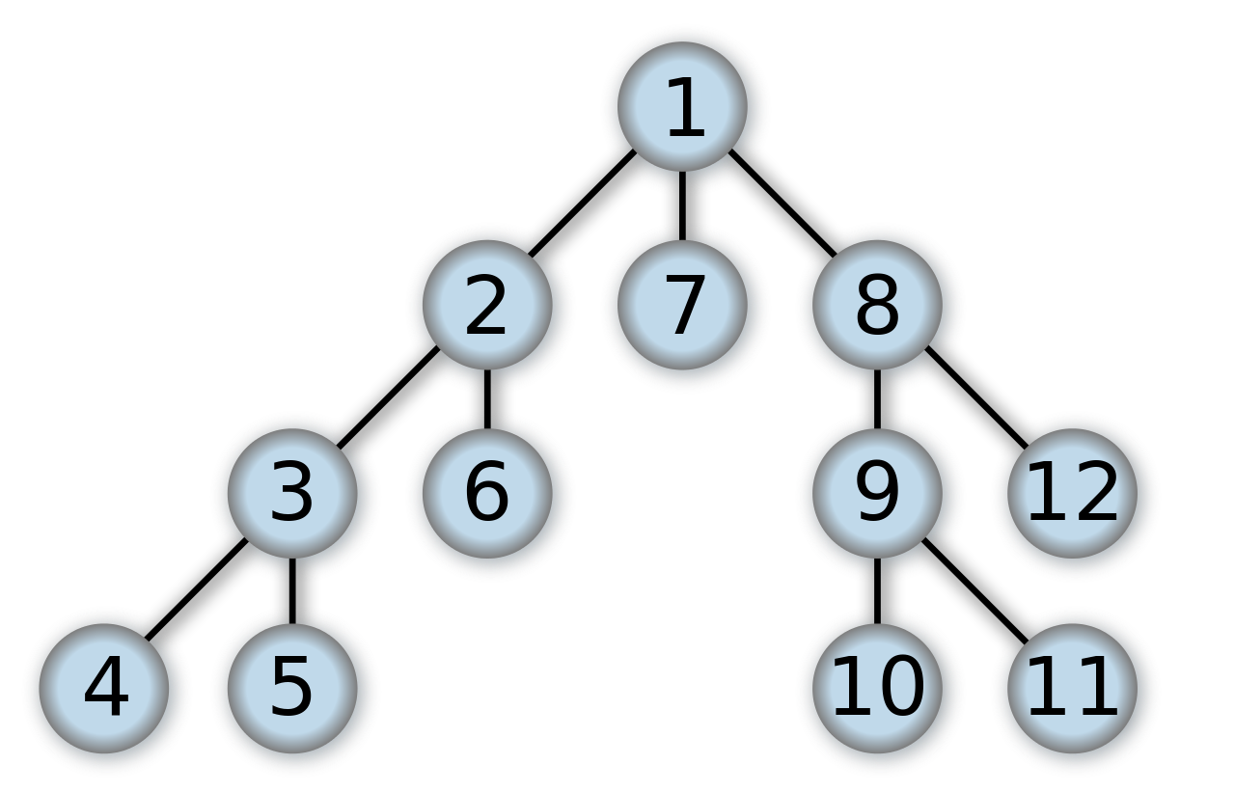
Figure 2. Source: Wikimedia Commons
Pseudo-code for DFS :
Create a queue
While the queue exists:
Take the last position added to the queue
If this was already visited, continue to the next last one
If this is your goal, finish
Get the successors of your current position
Reverse their order
Add them all to the queue
GUI and CLI outputs for DFS:
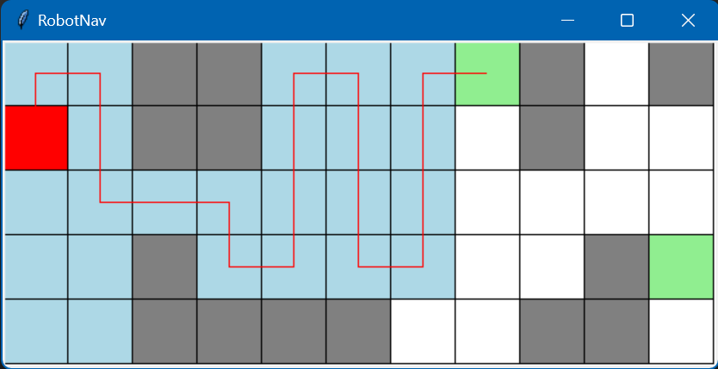
Figure 3: GUI output for DFS
resource.txt DFS
<Node (7, 0)> 26
['up', 'right', 'down', 'down', 'right', 'right', 'down', 'right', 'up', 'up', 'up', 'right', 'down', 'down', 'down', 'right', 'up', 'up', 'up', 'right']
The path found by DFS is by far the longest of the search methods (besides LPS), meaning that it is not optimal if the length path must be minimised. However, it is effective if any path must be found, and if such a path must be found as quickly as possible, since it minimises unnecessarily opened nodes.

Breadth-First Search
Unlike DFS, a Breadth-First Search (BFS) opens all nodes at a certain depth before proceeding to the next depth. It is also uninformed, but far more suited for the task of finding the shortest possible path to a goal than DFS. Figure 4 illustrates the order in which a BFS would visit nodes on a tree.
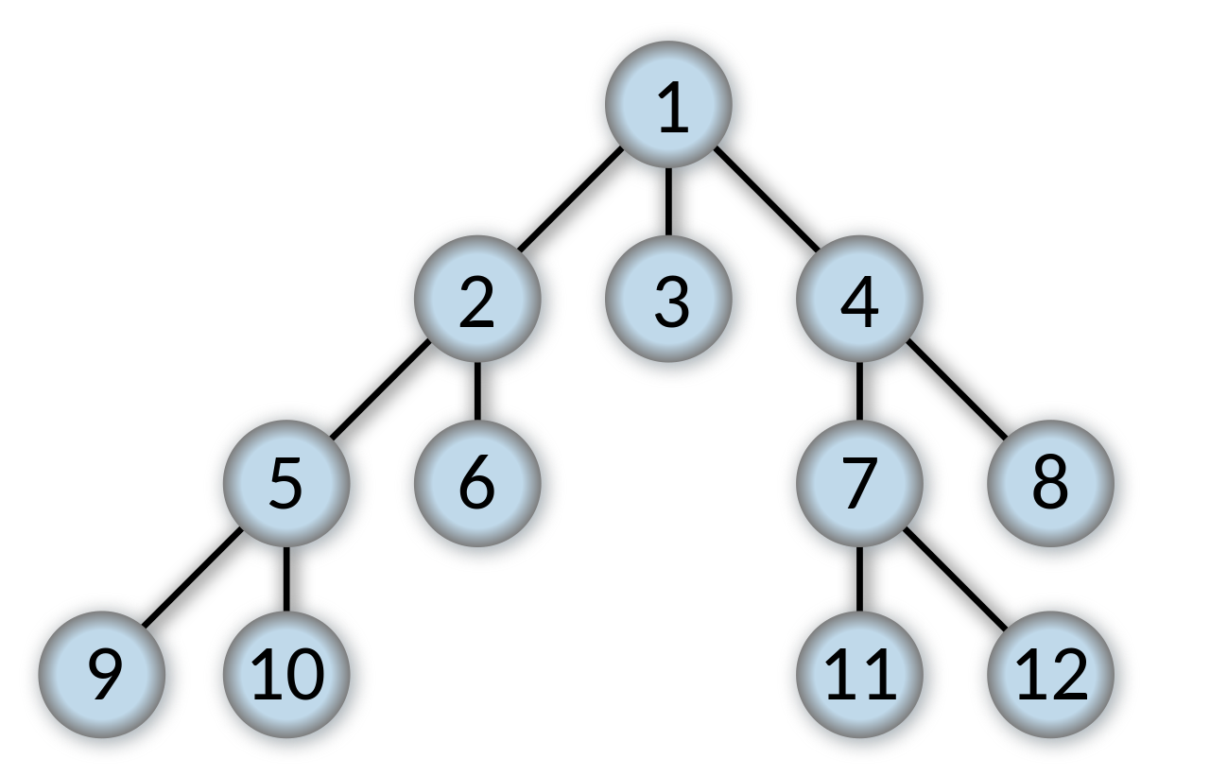
Figure 4. Source: Wikimedia Commons
Pseudocode for BFS:
Create a queue
While the queue exists:
Take the leftmost (oldest) position added to the queue
If this was already visited, continue to the next last one
If this is your goal, finish
Get the successors of your current position
Add them all to the queue
GUI and CLI outputs for BFS:

ut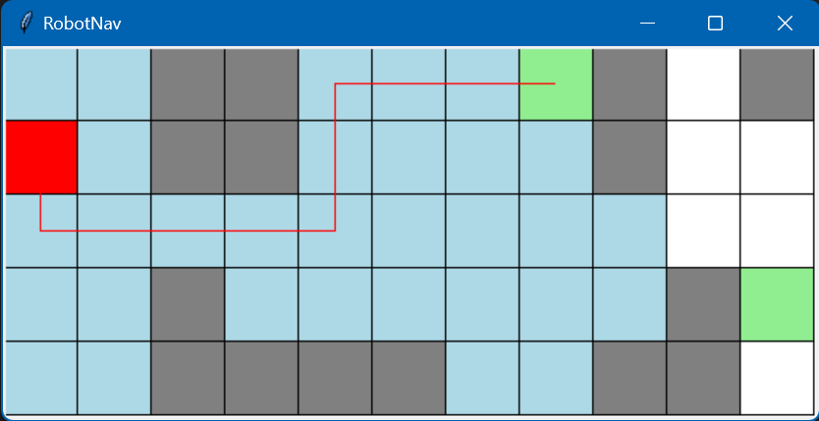
Figure 5: GUI output for BFS
resource.txt BFS
<Node (7, 0)> 33
['down', 'right', 'right', 'right', 'right', 'up', 'up', 'right', 'right', 'right']
Since it will search every path of a certain length before searching any longer paths, BFS is essentially guaranteed to find the shortest possible path to a goal, making it an ideal uninformed search algorithm in situations where the length of the solution must be minimised. However, its exhaustive exploration makes it somewhat inefficient, as demonstrated in this example, where it opened 33 nodes before finding a goal. In a large enough map, the number of unnecessarily opened nodes increases exponentially, dramatically slowing down the search.

Greedy Best-First Search
In mathematics, a greedy algorithm is an algorithm that makes the locally optimal choice at every stage. A Greedy Best-First Search (GBFS) measures all the successors by a certain heuristic, which estimates the cost of reaching the goal from that successor, and then expands the node that optimises this heuristic. Unlike DFS and BFS, it is informed, meaning that it knows the location of the goal and uses it to optimise its search. This generally finds the goal in less steps than a DFS and more efficiently than a BFS, although in some cases, the path found by a GBFS may not be optimal.
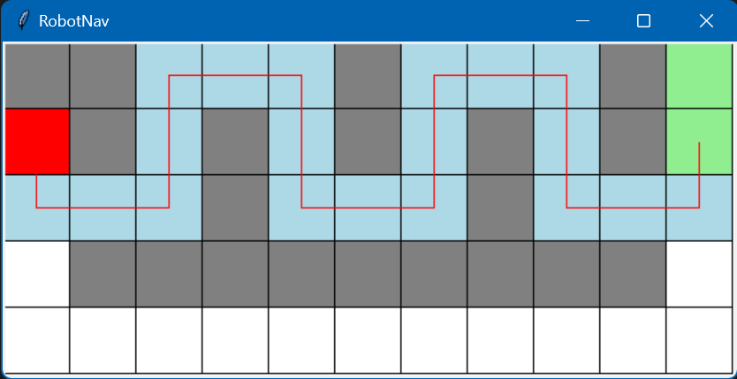
Figure 6: An environment in which GBFS results in a suboptimal route
Pseudocode for GBFS:
Create a frontier
Make it a heap
While the frontier exists:
Take the leftmost position in the heap, which is sorted by heuristic
If this was already visited, continue to the next last one
If this is your goal, finish
Get the successors of your current position
Add them all to the frontier sorted by heuristic
The heuristic used was the shorter of the two Manhattan distances to the goals.
GUI and CLI outputs for GBFS:
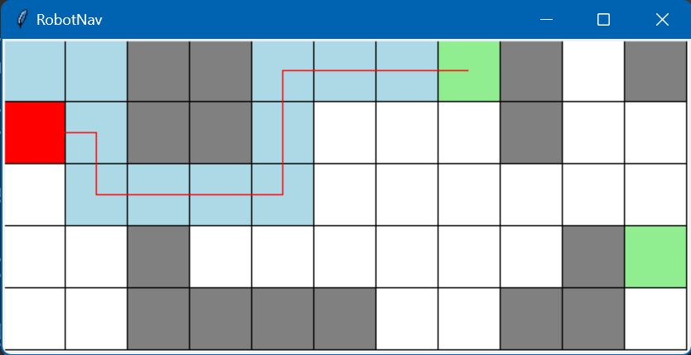
Figure 7: GUI output for GBFS
resource.txt GBFS
<Node (7, 0)> 13
['right', 'down', 'right', 'right', 'right', 'up', 'up', 'right', 'right', 'right']
In this situation, GBFS outperformed every other search algorithm, finding the shortest possible path with the minimum number of nodes opened. However, this was unlikely, as other search algorithms such as A*S tend to be more efficient than GBFS.

A* Search
The A* Search (A*S) is a version of the greedy best-first algorithm which, in addition to the estimated cost of reaching a goal from a certain node, also considers the estimated cost of reaching that node. It is widely used due to its simplicity and efficiency. Like GBFS, it is not guaranteed to find the optimal solution.
Pseudocode for A*S:
Create a frontier
Make it a heap
While the frontier exists:
Take the leftmost position in the heap, which is sorted by heuristic
If this was already visited, continue to the next last one
If this is your goal, finish
Get the successors of your current position
Calculate their g score
Add them all to the frontier sorted by heuristic + g score
GUI and CLI outputs for A*S:
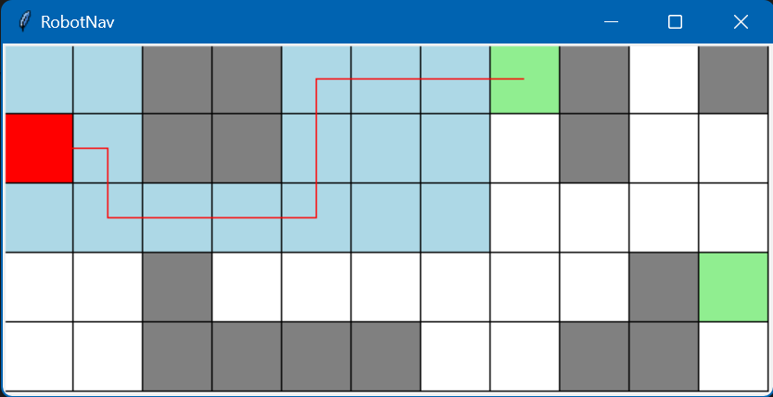
Figure 8: GUI output for A*S

resource.txt AS
<Node (7, 0)> 18
['right', 'down', 'right', 'right', 'right', 'up', 'up', 'right', 'right', 'right']
Like GBFS and BFS, A*S found the optimal path to a goal. Surprisingly, however, it was less efficient than GBFS, opening 18 nodes instead of 13. One possible explanation for this is that it considered all squares adjacent to its initial position optimal because their g scores were minimal, and thus it wasted nodes exploring them all before moving on. Likewise, when it entered the open area near the goal, it thoroughly explored it while GBFS headed straight towards the goal. Perhaps it was wrongly implemented, as the g score was reckoned by the g score of the current position + 1 instead of simply 1. The latter implementation was tested and returned a result identical to GBFS.

Custom Search 1
The uninformed custom search selected was a beam search. A beam search is a version of BFS which uses some heuristic to discard some of its successors, keeping only a predetermined number of best ones (10 in this case). Although it does use a heuristic, it is not completely informed since the heuristic does not directly play a role in the algorithm, but simply guides it. The beam search is a form of greedy algorithm.
Pseudocode for beam search:
Create a queue
While the queue exists:
Take the leftmost (oldest) position added to the queue
If this was already visited, continue to the next last one
If this is your goal, finish
Get the successors of your current position
Add them all to the queue
Sort the queue by some heuristic
Create a new queue with only the best 10 successors
GUI and CLI outputs for beam search:
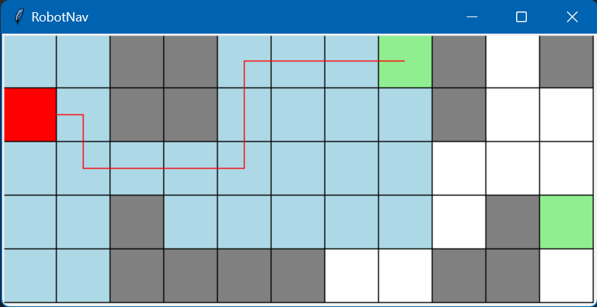
Figure 9: GUI output for beam search

resource.txt CUS1
<Node (7, 0)> 29
['right', 'down', 'right', 'right', 'right', 'up', 'up', 'right', 'right', 'right']
Due to the beam_width being so wide, the beam search was not a very large improvement on the BFS, only reducing the number of nodes by 4. Narrowing the beam width improves the results: for 8 the number of nodes is 27, for 6 it is 25, and for 5 it is 22.

Custom Search 2
For the informed custom search, the search algorithm selected was Iterative Deepening A* Search (CUS2). CUS2 is a modification of A*S which first attempts to find a solution with a specific depth, exhausts its options, then retries with a longer depth, repeating this process until it reaches the goal. It is inefficient due to the frequent revisiting of nodes, but occupies less memory since it does not save the results of earlier searches with a lower depth.
Pseudocode for CUS2:
For depth in range(max_depth):
Do an A* search with depth as the maximum path length
If you find a path, finish
GUI and CLI outputs for CUS2:
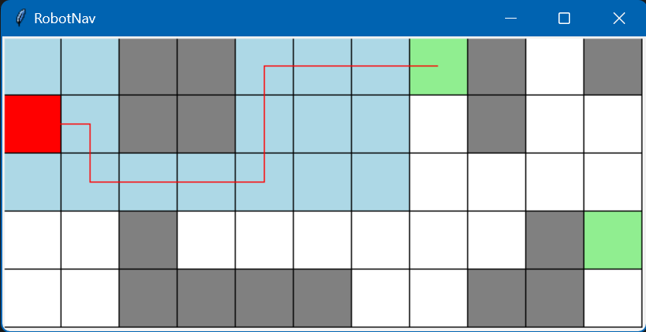
Figure 10: GUI output for CUS2
resource.txt CUS2
<Node (7, 0)> 159
['right', 'down', 'right', 'right', 'right', 'up', 'up', 'right', 'right', 'right']
CUS2 found the same path as BFS, GBFS, A*S and CUS1, but with a whopping 159 nodes opened. It had to repeat A*S about 11 times to find a goal. It did not even take less memory than GBFS, since its last search exceeded the number of nodes opened by GBFS and equalled that of A*S.

Testing
Many test cases were created to ensure that the code functions in any conceivable situation. Below is a selection of results from some of these test cases:

No method
Input: python search.py resource.txt
Output:
Error: Invalid input
Usage: python search.py <filename> <method> [gui]

Invalid method
Input: python search.py resource.txt a
Output:
Error: Invalid method

Invalid filename
Input: python search.py asdfgh.txt cus2 gui
Output:
FileNotFoundError: [Errno 2] No such file or directory: 'asdfgh.txt'

No reachable goal
Input: python search.py resource.txt cus2 (max_depth intentionally set too low)
resource.txt CUS2
No goal is reachable; 141

Generate GUI with no reachable goal
File "C:\Users\BoomF\OneDrive\Desktop\Uni\AI\RobotNav\GUI.py", line 33, in setup_environment
elif (x, y) in self.visited:
^^^^^^^^^^^^^^^^^^^^^^
TypeError: argument of type 'NoneType' is not iterable

Generate GUI with no reachable goal (visited error temporarily patched)
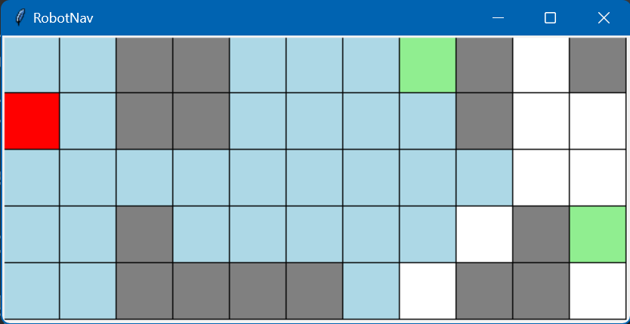
Figure 11
The GUI generates but the path does not. Note that the visited blocks border the goal but do not touch it.

Walls block goal
Input: python search.py resource.txt dfs gui (resource.txt and DepthFirstSearch.py temporarily changed)
Output:
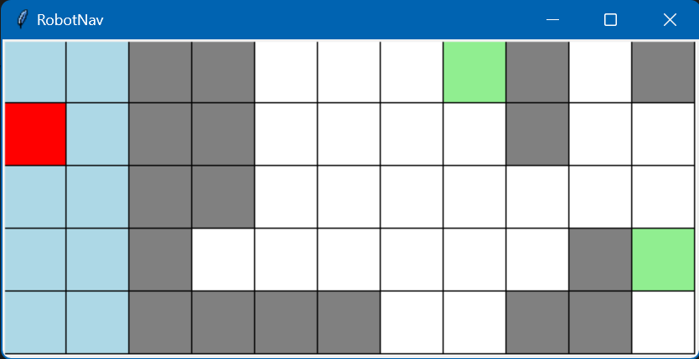
Figure 12
resource.txt DFS
No goal is reachable; 10

3 goals instead of 2
Input: python search.py resource.txt gbfs gui
resource.txt temporarily edited to add (7,4) as a goal
Output:
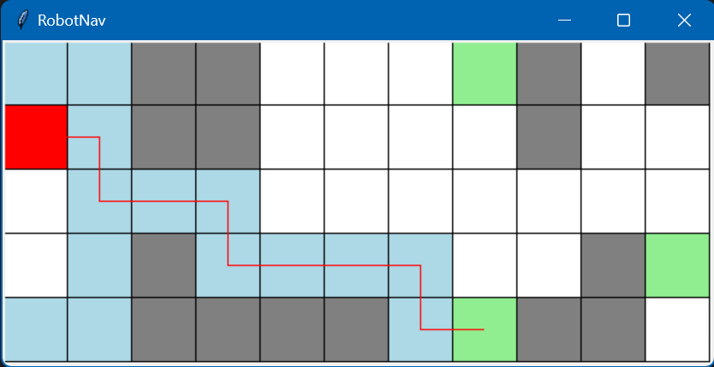
Figure 13

resource.txt GBFS
<Node (7, 4)> 16
['right', 'down', 'right', 'right', 'down', 'right', 'right', 'right', 'down', 'right']

Goal is in a wall
Input: Same as last experiment, but goal temporarily moved to (8,0)
Output:
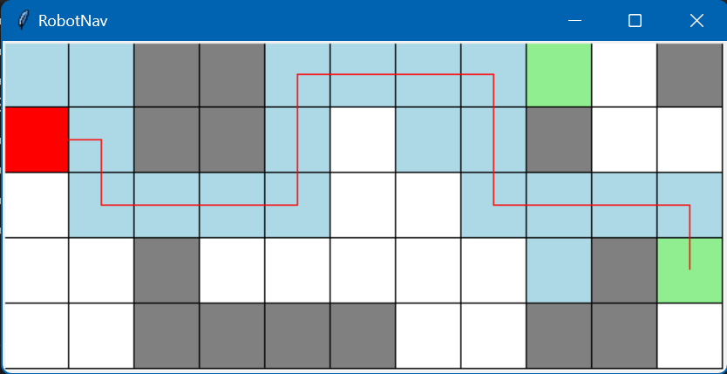
Figure 14
resource.txt GBFS
<Node (10, 3)> 21
['right', 'down', 'right', 'right', 'right', 'up', 'up', 'right', 'right', 'right', 'down', 'down', 'right', 'right', 'right', 'down']

Goal is in initial position
Input: Goal added at (0,1)
Output:
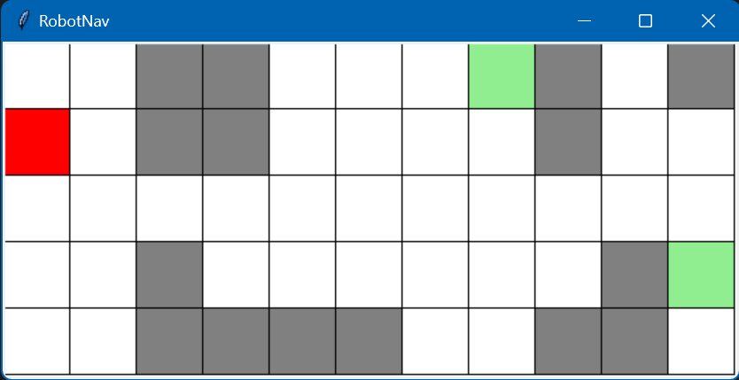
Figure 15
resource.txt GBFS
<Node (0, 1)> 1
[]

Research
Due to a misunderstanding of the instructions, an extra search algorithm called Longest Path Search (LPS) was invented, which attempts to find the longest non-self-intersecting path to the goal. It is not functional but was left in the code so that the effort put into making it would not go to waste.
Pseudocode for LPS:
Create a set called longest_path[]
Repeat a DFS 50 times
If the path you find is longer than the current longest_path, make it the longest_path
GUI and CLI outputs for LPS:
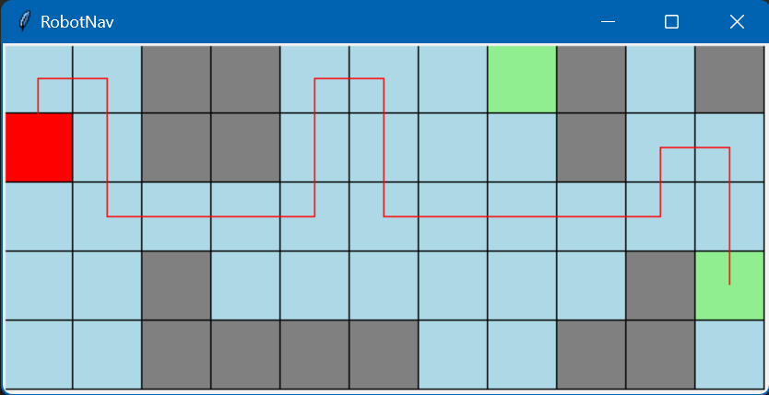
Figure 16: GUI output for LPS
resource.txt LPS
<Node (10, 3)> 366
['up', 'right', 'down', 'down', 'right', 'right', 'right', 'up', 'up', 'right', 'down', 'down', 'right', 'right', 'right', 'right', 'up', 'right', 'down', 'down']
LPS does not work. It is trivial to see that longer paths could be made than the one it found, even though it opened 366 nodes and searched every square in the grid. A functioning LPS search would have some real-life applications, such as helping a tourist visit every part of a region without visiting the same place twice, or aiding exploration in open-world games.

Resources
- Wikipedia: referenced for information.
- Wikimedia Commons: source of explanatory images.
- ChatGPT: coding assistance and explanations on search algorithms. However, most of its code was not functional and had to be modified.
- "Artificial Intelligence: A Modern Approach, 4th US ed." by Stuart Russell and Peter Norvig: a helpful resource.

